From lactation experts to breastfeeding groups, Women, Infants, and Children (WIC) Supports your breastfeeding journey. Visit WICHelpNY.org and “Chat with Wanda” to see if WIC is right for you.
Phone Support
Local Counseling
Classes
US Office of Women’s Health
800-994-9662
Free phone support available Mon-Fri, 9am-6pm EST
English and Spanish

InfantRisk Center Helpline
806-352-2519
Up-to-date information on using medications while breastfeeding
English and Spanish

La Leche League USA
877-452-5324
Free phone support available 24/7
English and Spanish

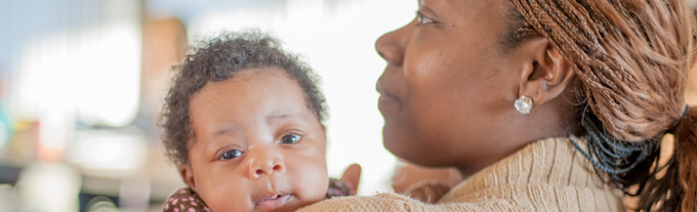
Free Support Groups
Good Samaritan Hospital
631-376-4159
https://www.chsli.org/childbirth-class-registration
Monthly classes, see website to register
Cost: $30 per couple, fee reduced or waived if needed
Free Breastfeeding Cafés Wednesdays 1:00-2:30 pm
In-person: Perinatal Center at 661 Deer Park Avenue
Virtual:https://chsli-org.zoom.us/j/98403827381

St. Catherine of Siena Medical Center (Smithtown)
Free prenatal breastfeeding class (generally for those who plan to deliver at St. Catherine) on Thursdays at 6:00pm
Call 631-870-3444 to register
Free support group Tuesdays 1:00pm, call 631-862-3845 for more details

South Shore University Hospital
Free classes
To register or for more information please call (631) 894-5282 or email wandria@northwell.edu

Women, Infants and Children (WIC)
https://www.suffolkcountyny.gov/departments/health-services/patient-care/WIC-program
OR
https://medicine.stonybrookmedicine.edu/family_population_preventive_medicine/divisions/nutrition/wic
Provides nutrition and breastfeeding support
You do not need to use formula to get WIC benefits!
Find your closest location at the above websites

Allied Breastfeeding Support
https://alliedphysiciansgroup.com/patient-resources/breastfeeding-support/
1-866-621-2769
In office or virtual appointments
Prenatal classes
Location-specific support groups
Breast pump rentals and sales

Long Island Lactation Consultant Association
www.lilca.org
Find a Lactation Consultant or local breastfeeding support group

Long Island Doula Association
631-574-2205 | info@lidoulas.com
www.lidoulas.com
Doula services, breastfeeding support, and childbirth education classes
Families in Crisis Fund to help those with limited resources access their services

Updated November 2023
Breastfeeding/Chestfeeding Resources
La Leche League
https://www.lllusa.org/
See website for more details

Wyandanch Lactation Support Group
631-513-5987
Sun River Health Martin Luther King, Jr.
In conference room
1556 Straight Path, Wyandanch, NY 11798
1st and 3rd Wednesday of each Month
11:30 am - 12:30 pm

BFREE Virtual Lactation Support
Free virtual support groups at bit.ly/BFREElactationsupport
English: Every Tuesday from 7-8pm; Every 1st and 3rd Thursday of the month from 12-1pm
Spanish: Every 1st and 3rd Tuesday of the month from 6-7pm

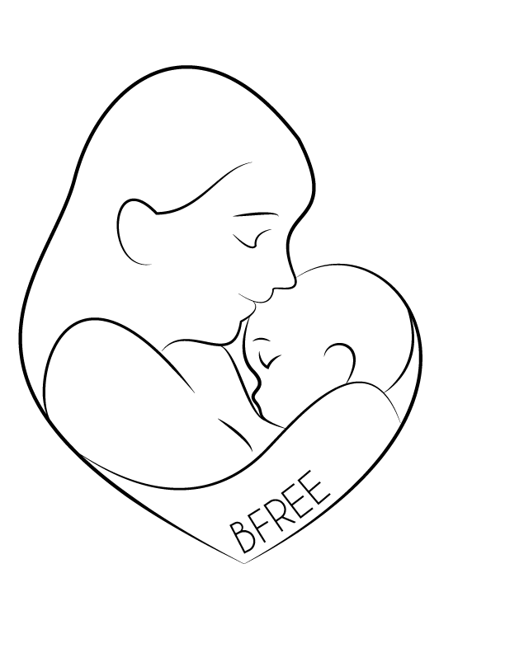

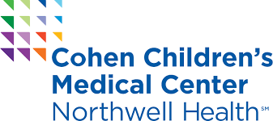
Kelly Mom
https://kellymom.com/
Written by a breastfeeding mother and International Board-Certified Lactation Consultant (IBCLC) this website provides evidence-based information on breastfeeding and parenting.

The Office of Women’s Health
https://www.womenshealth.gov/breastfeeding/
The Office of Women’s Health is part of the Department of Health and Human Services and provides breastfeeding information and resources, including sections specifically for mothers returning to work and African-American families.
English/Spanish

Feeding Your Baby
http://www.feedingyourbaby.org/
Feeding Your Baby is a place for you to learn about infant nutrition. There are 6 units that match important stages in the baby's first 6 months of life. This useful information and nutrition advice will help you reach breastfeeding goals.
English/Spanish

La Leche League International
https://www.llli.org/
La Leche League International—their local chapters are listed under support groups, but their webpage also provides a lot of helpful information as well as mother-to-mother forums, FAQ-Answer pages, and podcasts.
Multiple Languages

Phone Apps (available on iphone and android)
Baby Connect: Helps parents and child care centers track daily activities and developmental milestones
Baby Nursing: Helps families track baby’s nursing progress, growth, diaper changes, doctor’s visits, sleep, baths, medications, vaccinations and activity.
Baby Shushing: Helps sooth fussy babies with rhythmic “shush” sound.
Irth: Irth, as in “Birth” without the “B” for bias, is the only app where you can find prenatal, birthing, lactation, postpartum, and pediatric reviews of care from Black and Brown women, their partners, and doulas.

Funded by the New York State Department of Health, Cohen Children’s Medical Center’s Breastfeeding, Resiliency, Engagement, and Empowerment (BFREE) coalition supports mothers in reaching their breastfeeding goals.

Contact us at BFREE@northwell.edu with any questions or comments!

BFREE
Under New York Insurance Law, insurers must cover maternity care including lactation support services such as counseling, education, and classes in breast- and bottle-feeding, and breastfeeding equipment such as pumps.

Call your insurance and ask how to get a breast pump. If they will not provide a pump, call the appropriate complaint line:
Medicaid:
1-800-206-8125
Other insurances:
1-800-342-3736

Breast Pumps
Online Resources
Your Rights as a Breastfeeding/Chestfeeding Parent
You have the right to breast/chestfeed your child in any public or private location (NY Civil Rights Law 79-e).
You have the right to pump breast/chest milk at work (NY Labor Law Section 206-c)
Your employer must provide a reasonable amount of unpaid break time for parents to express breast/chest milk for up to 3 years following the child’s birth
Upon request, an employer must provide a room (not a bathroom) for breast/chestfeeding parents to express breast milk
Look at the Breastfeeding Mother’s Bill of Rights (www.health.ny.gov/publications/2028) or ask your healthcare provider for more information.

